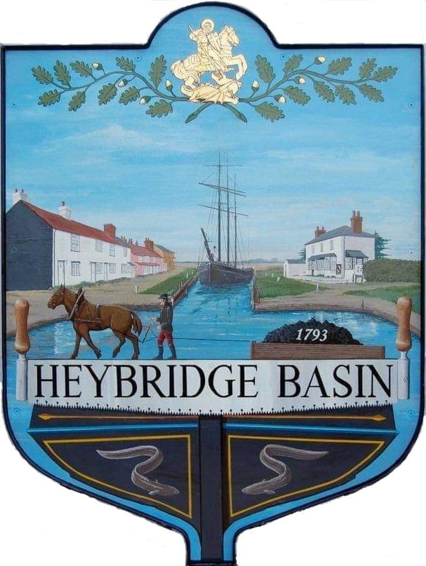

HEYBRIDGE BASIN PARISH COUNCIL

Minutes of the Full Council meeting of Heybridge Basin Parish Council held on Tuesday 18th July 2023 at 6.30pm

Present – Cllrs M. Hodges (Chair), R. Bryson (Vice Chair), M. Hobden C. Swann, and J. Sjollema.

Also present – G. Lake – Clerk, District Cllrs N. Spenceley and N. Swindle and 2 members of public.

Recording of meetings
Please note, the Council may have recorded any part of this meeting held in open session. Members of the public who attended the meeting and spoke are deemed to have given permission to be included in the recording.

23/43 Chair’s Welcome
The Chair opened the meeting and advised members of the public that the Clerk was recording the meeting.

23/44 Apologies for Absence.
- To receive and accept apologies for absence.
Apologies for Cllrs Edmond and Howat were approved.

23/45 To receive Declarations of Interest in accordance with the Council’s Code of Conduct and with section 106 of the Local Government Finance Act 1992.
Cllr Hobden – Non-Pecuniary – HBSA, Basin Oars and HB Rivercare.

23/46 To sign as a correct record the minutes of the full council meeting held on 20th June 2023.
The Minutes as previously circulated were agreed as a correct record.

23/47 To receive a report from the District and County Councillors for the area on any matters of interest.
Reports from the District Cllrs and Cllr Durham had been circulated.

Cllr Swann arrived at 6:34pm

23/48 Finance.
- To approve
- Payment requests for June/July 2023.
The Payments as previously circulated were approved.
- Receipts for June/July 2023.
The receipts as previously circulated were approved.
- Accounts for the three months to 30th June 2023
The accounts as previously circulated were approved.
- To appoint one member has Bank Verifier.
Cllr Howat had informed the Clerk prior to the meeting that he would be happy to continue this role. It was resolved that Cllr Howat would continue to be the Bank Verifier.

23/49 Website/Emails
  - To receive an update from the Clerk and agree any action to be taken.
Clerk informed members that the annual hosting and support fee for the Website was due for renewal and that the support from the current host had been lacking. The Clerk had been researching options regarding the website and emails. It was resolved for the Clerk to continue the research.

23/50 Public Forum
1 member of public spoke about their planning application (Leanna House).

23/51 Speed Watch
- To receive an update from the WG and agree any action to be taken.
It was resolved that the Clerk would be the lead co-ordinator for all volunteers. It was resolved to give delegated authority to the Clerk and allow the WG to select the locations for monitoring.

23/52 DMCP
- To receive an update from the WG and agree any action to be taken.
MDC had confirmed that planning permission was not required for the works to the access road. The WG completed the find a contract form as previously agreed by Council and this was now live with a closing date of 31st October 2023.

The WG met and discussed the quotes obtained for the felling to the Leylandii and recommended that Blackwater Tree Specialists be selected. It was resolved to accept the quote from Blackwater Tree Specialists and for the Clerk to organise a date for the works to be undertaken.

The new signs for the car park are due to be installed on Wednesday 19th July.

23/53 United Reformed Church
- To discuss the URC and agree any action to be taken.
It was resolved that the Clerk would nominate the URC to be listed as an Asset of Community Value with MDC as well as write a letter to both of the buildings current owners.

23/54 Noticeboard near Jolly Sailor
  - To receive an update from Cllr Hodges and agree any action to be taken.
It was resolved to accept the quote of £20.00 from Blackwater Printing for sign to be screwed on to the noticeboard.

23/55 D-DAY 80
- To receive an update from the Clerk and agree any action to be taken.
It was resolved that the Council would like to organise an event to celebrate D-Day 80 in June 2024. It was resolved to create a Working Group which would consist of Cllrs Bryson, Hobden and Hodges, as well as any other interested parishioners.

23/56 Planning Applications
- To consider any planning applications received after the publication of the agenda and to agree the action to be taken.

23/00636/HOUSE – 5 St Georges Close – Single storey side extensions.
It was resolved to recommend the granting of planning permission.

Cllr Sjollema arrived at 7:10pm

23/00650/PACUCD – Leanna House, Lock Hill - Conversion of existing workshop building to 2-bedroomed residential dwelling including internal and external alterations.
It was resolved to recommend the granting approval of the change of use application.

23/57 Clerk’s Report
- Land adjacent to St Georges Church – A notice had been issued asking for consent or objection to the application. The notice expires at noon on 2nd September.
- Bus Shelter Land – Clerk informed members that she was unable to seek confirmation of Land Ownership. It was resolved for Cllr Hodges to speak with Joy.
- Basketball/Netball Hoop Funding – Clerk informed members that the Community Grants application with Tesco has been accepted and shoppers can now put tokens into their chosen charity.
- MDC – The Clerk was still awaiting updates from MDC regarding the Goal Posts and the Pedestrian Sign for St George’s Close.

It was noted that the Clerk had used DMCP once for a meeting with the WG.

23/58 Correspondence
- To note correspondence received and any actions to be taken.
Correspondence was noted and responses were agreed.
It was resolved that Cllr Edmond would draft a letter to Essex County Council regarding the response from the EA.
It was noted that the Clerk and Cllrs Hodges, Bryson, Hobden, Sjollema and Swann would be interested in attending the Defibrillator Training.

23/59 Local Issues
- To note any items of inclusion on the agenda for the next meeting of the Parish Council.
There were none.

There being no further business the meeting closed at 07:37pm
Provisional Date of the next Council Meeting Tuesday 19th September 2023.

Clerk Contact details: clerk@heybridgebasinpc.org.uk
Website: www.heybridgebasin-pc.gov.uk

